Import Order user guide

Order file can upload in CSV & Xlsx format.

Column information

* PoNumber is mandatory
* ProductReference is mandatory
* ProductReferenceDescription is mandatory
* ETD is not mandatory. If ETD available then the date format should be in dd/mm/yyyy format. System not support any other date format.   
    
  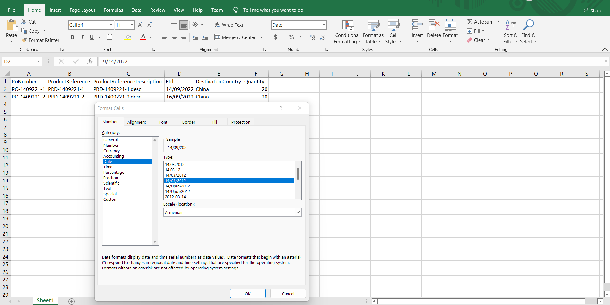
* Destination country is not mandatory.
* Quantity is mandatory. It should be greater than 0.
* Barcode is not mandatory.
* FactoryReference is not mandatory.
* Color Code is mandatory if it is softline
* Color Name is mandatory If it is softline

\*\*\*\*\*\*\*\*\*\*\*\*\*\*\*\*\*\*\*\*\*\*\*\*\*\*\*\*\*\*\*\*\*\*\*\*\*\*\*\*\*END\*\*\*\*\*\*\*\*\*\*\*\*\*\*\*\*\*\*\*\*\*\*\*\*\*\*\*\*\*\*\*\*\*\*\*\*\*